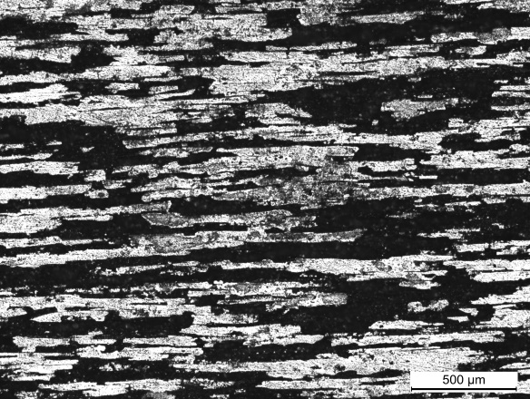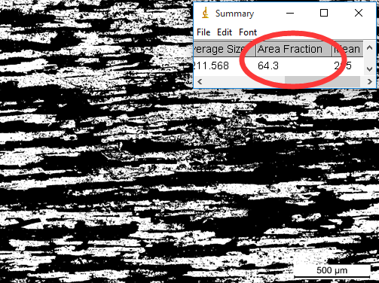
(a)
(b)
Corrosion area
Fig. S1 (a) Corrosion morphology after cyclic polarization in 0.1 mol/L HCl + 1 mol/L NaCl at the temperature of 318 K and (b) its corresponding binary image using ImageJ2x software. The corrosion fraction is 64.3% from the analysis of this binary image.

