Dr. Fatma Bayrakçeken Nişancı Department of Chemistry,
Phone: +90 442 741 5229 Faculty of Science,
Fax: +90 442 7413334 Atatürk University
E-mail: fbayrakceken@atauni.edu.tr 25240 Erzurum, TURKEY

December 23, 2019
Dear Kwang-Chul Roh,
Thank you for sending us the reviewer and the editor comments on the manuscript JECST-19-0010.

“Growing High-Quality Ir-Sb Nanostructures by Controlled Electrochemical Deposition”.

We thank both the reviewer and editor for their kind recommendation and thoughtful comments. We have revised our paper based on their comments and suggestions. Our response and the changes implemented in the revised manuscript are provided below. For your convenience every changes/additions have been highlighted in yellow.

Reviewer #1:

The following manuscript whose title is 'Growing High-Quality Ir-Sb Nanostructures by Controlled Electrochemical Deposition' can be accepted with some major revisions.

First of all thanks to the Reviewer for his/her kind comments about our manuscript.

Q1 SEM-EDS mapping should be carried out and attached to Fig. 2 and 3 to visualize elemental distribution.

Our Reply: Thanks to the Reviewer for the suggestion. Highly crystalline Ir-Sb nanoflowers were fabricated using a electrochemical approach based on underpotential deposition (UPD) oxidation of Ir and Sb atomic layers from an aqueous suspension. Electrochemical UPD and mechanism of the Ir and Sb atomic layers were studied by cyclic voltammetry and potential-controlled electrochemical deposition techniques. The morphologies, crystallinity, stoichiometries and optical properties properties of the as-electrodeposited Ir-Sb materials were analyzed using scanning electron microscopy (SEM), atomic force microscopy, X-ray diffraction (XRD), X-ray photoelectron spectroscopy (XPS), energy dispersive spectroscopy (EDS), UV-Vis absorption and Raman techniques. Numerous SEM images of the samples formed at different electrodeposition times and in different solution medium were taken. Furthermore, AFM images supporting SEM images were also obtained for the determination of surface morphology. The elemental compositions (Ir/Sb) of electrodeposited Ir-Sb were determined by EDS. A representative EDS line mapping spectrum is presented in 1, since we observed that the EDS spectra of Ir-Sb deposits obtained in acidic conditions are identical. Quantitative analysis of the spectrum reveals that the atomic ratio of Ir to Sb is 1:1 with compositional homogeneity.
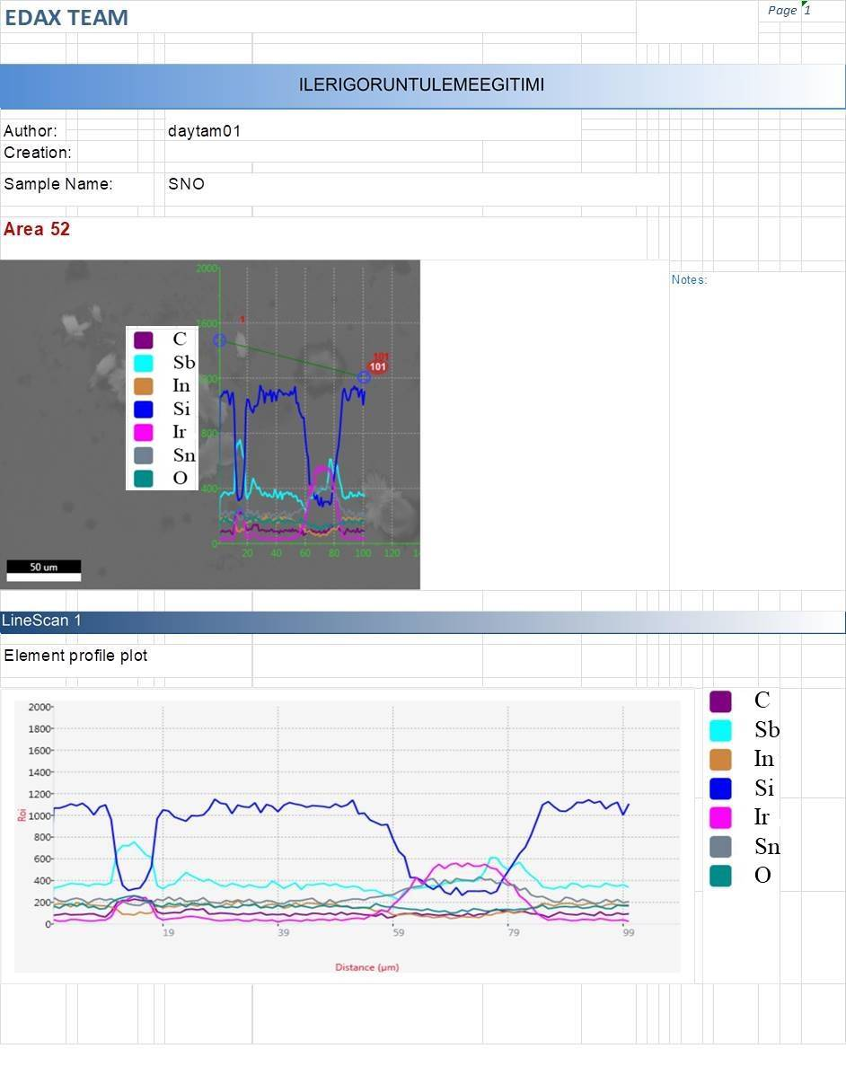
1. The EDS line mapping of Ir-Sb thin film grown on ITO substrate.
Also the raman mapping had been taken. The mapping given in Fig 6 at the article provides information about the surface such as SEM and AFM data. Raman mapping is a powerful technique for generating detailed chemical images based on a sample’s Raman spectrum. 2 and 3 (below) show the Raman mapping of the Ir-Sb nanostructures, shaped as nanoflowers of different sizes and electrodeposited on ITO electrodes at a UPD potential of Ir and Sb for 60, 30 and 15 min. As seen from these images, the size of the nanostructures with well-faceted morphology increases in every dimension with increasing deposition time, although These results also revealed that the size of the Ir-Sb nanostructures could be tuned simply by controlling the deposition time.

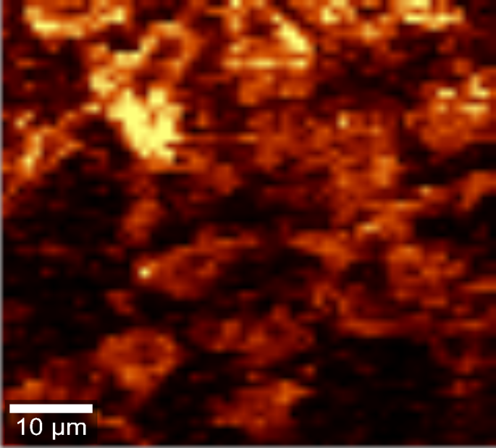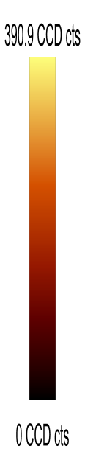

2. Micro-Raman mapping as measured by planar oriented laser polarization of Ir-Sb (deposition of 60 min at -200 mV) at room temperature on an ITO coated glass electrode.

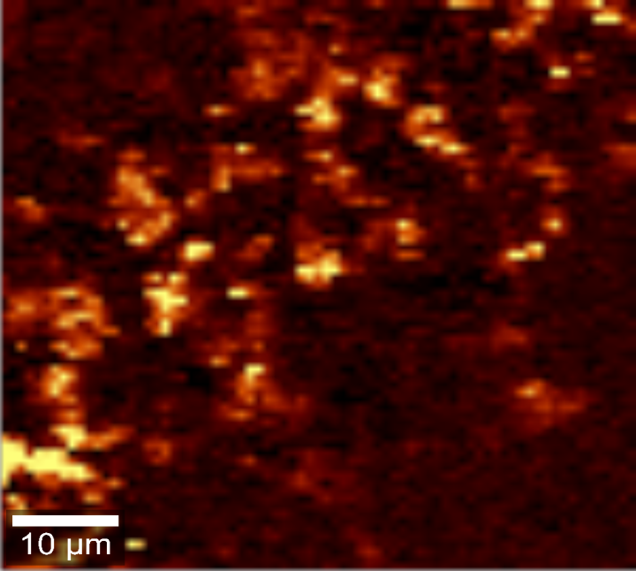
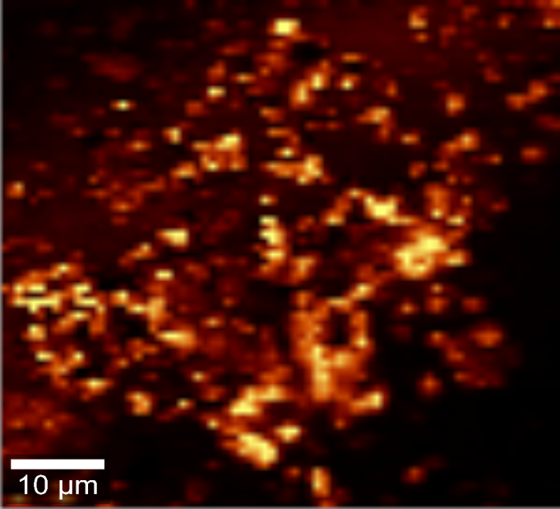

3. Micro-Raman mapping as measured by planar oriented laser polarization of IrSb (deposition of 15 and 30 min at -200 mV) at room temperature on an ITO coated glass electrode.

Q2. Due to the limitatoin of EDS, quantitative analysis is not incorrect.

It is very careful to quantitatively represent the component ratios only with EDS results. Add an analysis to determine quantitative elements.

Our reply: Thanks to the reviewer for his/her valuable suggestion. The elemental compositions (Ir/Sb) of electrodeposited films have been determined by the EDS technique. EDS analysis also supports these conclusions. The EDS spectrum shows Ir and Sb as the only detected elements, with a ratio close to 1 in the these nanostructures, except trace amounts of In, Sn, O, Si and C due to from the subsrate electrode. All of these XRD and XPS results suggest that the necessary amount of Ir and Sb ions for the UPD of Ir-Sb can be supplied from an aqueous Ir and Sb suspension.

A representative EDS spectrum for Ir-Sb consists of Ir and Sb peaks indicating that the film is pure phase with an approximate stoichiometry of 1:1 (4). In addition to this spectrum, all the EDS data are also given in Table 1. As shown in Table 1, atomic percentage of the Ir:Sb in films is in close agreement with the volumetric ratio of the elemental precursors taken in the solution during electrodeposition. We found that the quantitative atomic ratio of Ir and Sb are approximately Ir-Sb films a ratio which is close to 1:1 stoichiometries. (The atomic percentage in film by EDS Ir/Sb)

Table 1.
The elemental compositions (Ir/Sb)
 |  | The molar percentage |  |  |  |  | The weight percentage |  |  |  |  | The atomic percentage in film by EDS
 |  |  | Ir Sb |  |  |  |  | Ir Sb |  |  |  |  | Ir |  | Sb
Ir /Sb |  |  | 50 50 |  |  |  |  | 21,9 27,8 |  |  |  |  | 7 |  | 8,4
4. EDS spectrum of these nanostructures generated after 60 minutes deposition.
The table showing the elemental composition in the paper is placed on the EDS graphic. (Figure 3)

Q3. The figures are low resolution and difficult to discern. It is recommended to revise it at high
resolution.

Our reply: Thanks to the Reviewer for the suggestion. Corrections were made on the low resolution and difficult-to-understand images mentioned in the article. The scales in the SEM images are now more understandable.

Q4. Overall, the purpose of the paper is not clear. Please review the use or context of the word again.

Our reply: Thanks to the Reviewer for his/her careful reading. We proof-read the whole manuscript carefully and the English level was improved by a Language Service. Herein I summarized the purpose of the manuscript:

Thermoelectric materials have become a promising technology to generate electricity from heat that can be considered waste. The main basis of thermoelectric materials is the electric current which is formed by the temperature difference between the two ends of the material. In other words, if such materials are hotter than the other, electricity will be produced as a feature of the material. Therefore, it is possible to produce electrical current from computers, cars or other imaginable things. However, the cost of this technology is high and the materials that are suitable for it are either weakly thermoelectric conversion efficiency or rather expensive. Therefore, the increasing need for alternative energy sources also increases the interest in the development of new generation thermoelectric materials. Examples of thermoelectric materials are semiconductor alloys having the general formula T-Sb prepared with Group VIII (Co, Rh and Ir) transition metals (T) and Sb. Here, we report a electrochemical process based on the deposition of Ir and Sb precursors from the same solution containing Ir and Sb at a constant potential, which is determined from the upd potentials of Ir and Sb. Additionally, this method allows easy control of the thickness of the material by simply using different deposition times and has some advantages over the present electrochemical deposition methods to overcome the deposition problems mentioned above. However, the physical properties of the Ir-Sb are not well known and their electrochemical synthesis is not available in the literature. The aim of this article is to synthesize Ir-Sb films which have never been synthesized by electrochemical methods (upd) and to gain the morphological and optical properties of these nanoflower films.

In this context, the aim of the article has been tried to be stated in the introduction and abstract.

We feel that the revised version is now ready for publication in Journal of Electrochemical Science and Technology.

Thank you for your consideration.
Sincerely yours,
Dr. Fatma Bayrakçeken Nişancı, Assistant Professor of Chemistry

