Synthesis and applications of Dicationic Iodide Materials for Dye-Sensitized Solar Cells.

Supporting Information.

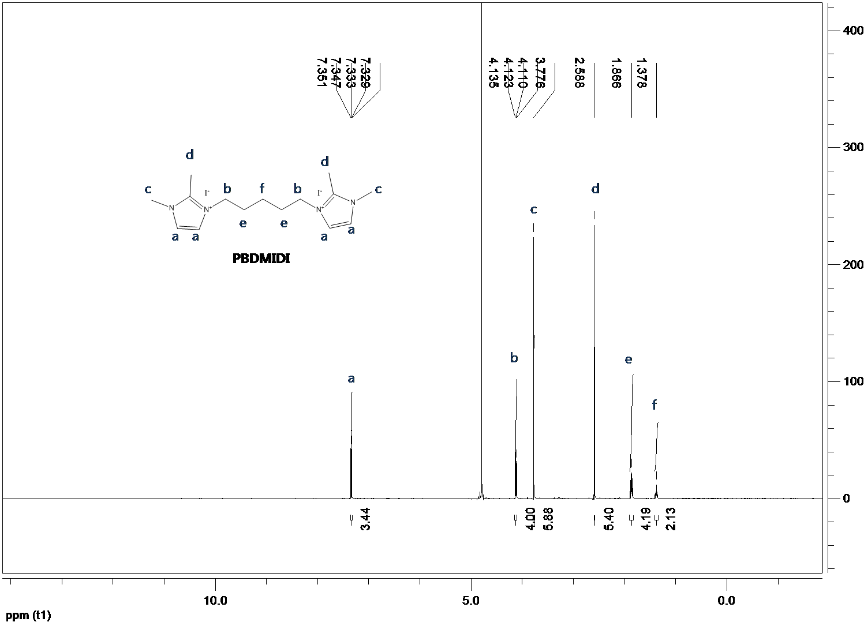
Fig. S1. ¹H NMR spectrum of PBDMIDI
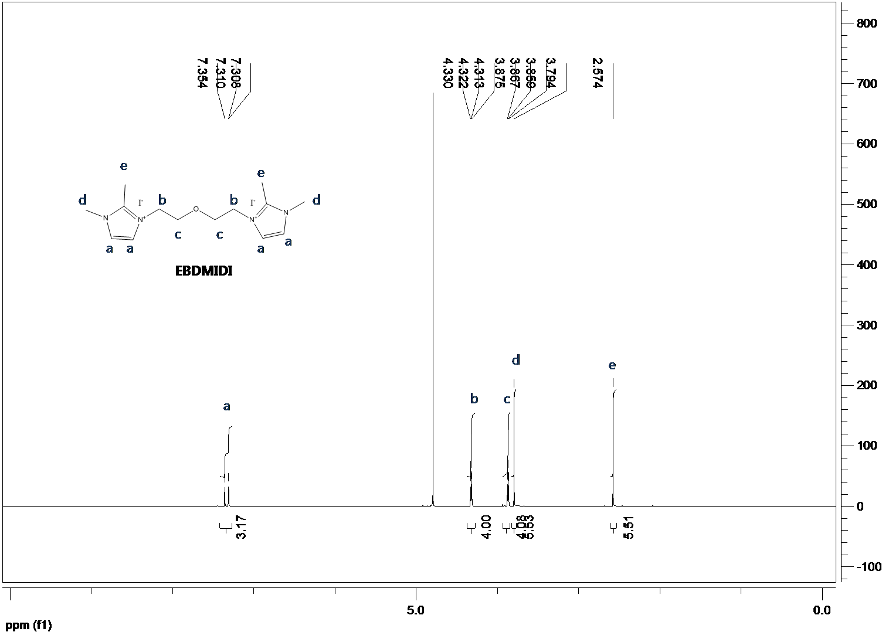
Fig. S2. ¹H NMR spectrum of EBDMIDI
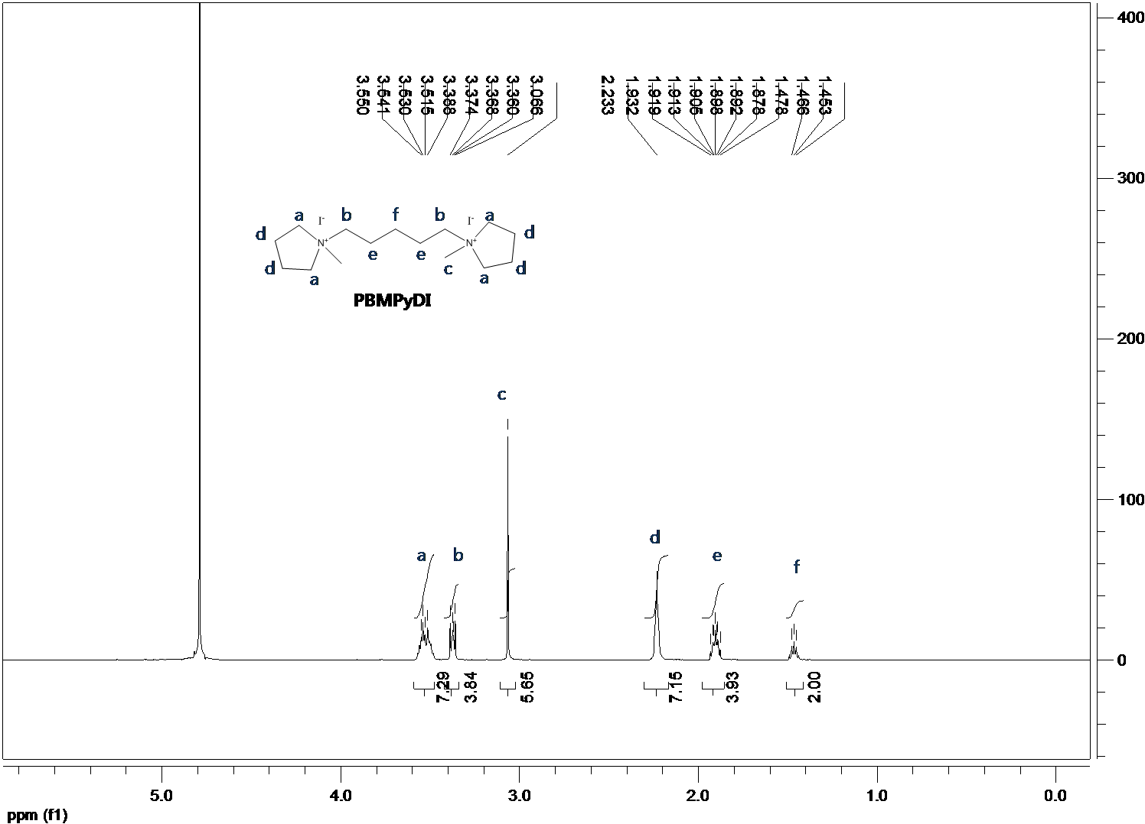
Fig. S3. ¹H NMR spectrum of PBMPyDI

