Supporting Information

Effect of nanostructures of Au electrodes on the electrochemical detection of As

Kanido Camerun Kastro, Min Ji Seo, Hwakyeung Jeong, Jongwon Kim*
Department of Chemistry, Chungbuk National University, Cheongju, Chungbuk 28644, Korea

*Corresponding author. E-mail: jongwonkim@chungbuk.ac.kr

Table S1. Electrochemical surface area (ESA) and normalized currents (I_{norm}) for As detection on various Au nanostructures with different deposition charges (Q_{d})
Electrodes
Nanoplate Au |  |  | Dendritic Au |  |  | Nanospike Au
Q_{d}  (C) | ESA  (cm²) | I_{norm}  (µA/cm²) | Q_{d}  (C) | ESA (cm²) | I_{norm}  (µA/cm²) | Q_{d}  (C) | ESA (cm²) | I_{norm}  (µA/cm²)
0.01 | 0.256 | 225.13 | 0.005 | 0.158 | 106.83 | 0.0025 | 0.104 | 172.24
0.019 | 0.294 | 261.45 | 0.008 | 0.211 | 99.38 | 0.005 | 0.149 | 164.86
0.028 | 0.313 | 216.18 | 0.014 | 0.454 | 74.43 | 0.01 | 0.143 | 131.33
 |  |  | 0.025 | 0.484 | 63.56 | 0.02 | 0.307 | 97.57

Table S2. The relative ratio of (111) and (100)/(110) Au facets on nanostructured Au electrodes
 | Electrodes
 | Flat Au |  | Nanoplate Au |  | Dendritic Au |  | Nanospike Au
 | (111) | (110)/(100) | (111) | (110)/(100) | (111) | (110)/(100) | (111) | (110)/(100)
Charges for Pb stripping (µC) | 1.84 | 2.83 | 18.1 | 5.86 | 9.23 | 19 | 5.18 | 7.04
Ratio of  (111) over (100)/(110) | 0.65 |  | 3.09 |  | 0.49 |  | 0.74
The stripping charges were measured by integrating the area under the anodic peaks during Pb UPD process as shown in Figure 3.
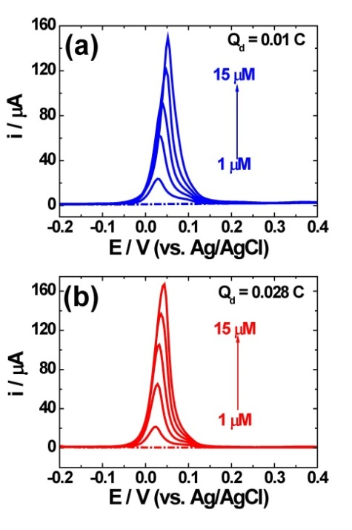
Fig. S1. SWASV of nanoplate Au electrodes at 1, 3, 6, 10, and 15 µM As(III) in 1 M HCl.

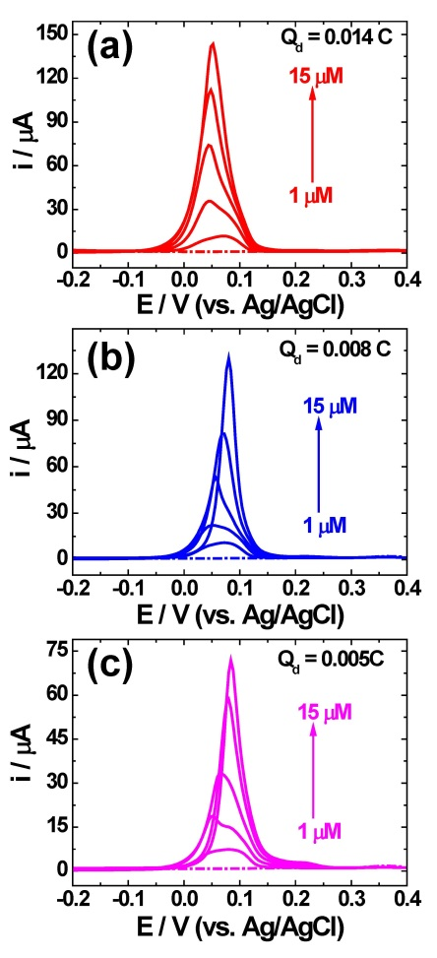
Fig. S2. SWASV of dendritic Au electrodes at 1, 3, 6, 10, and 15 µM As(III) in 1 M HCl.
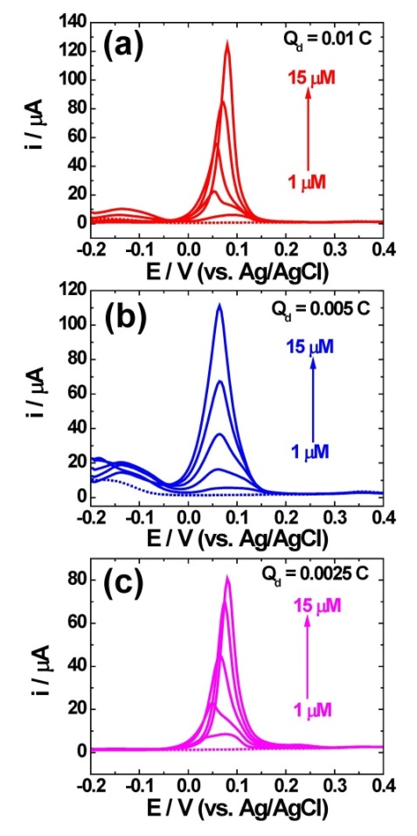
Fig. S3. SWASV of nanospike Au electrodes at 1, 3, 6, 10, and 15 µM As(III) in 1 M HCl.

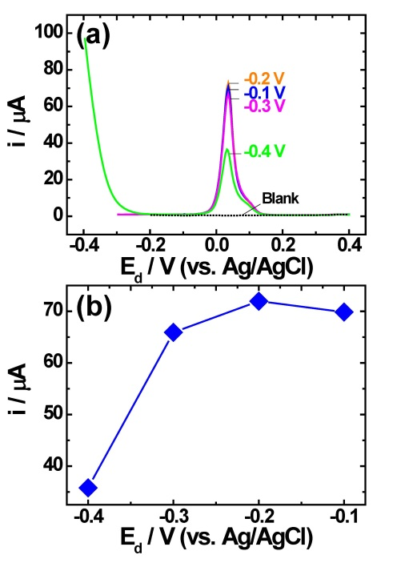
Fig. S4. (a) SWASV response of nanoplate Au electrode in 3 µM As(III) + 1 M HCl at various deposition potentials with deposition time of 150 s. (b) Peak current vs. deposition potential curve.

Table S3. Comparison of the differences in sensitivity between flat Au and nanoplate Au electrodes at a deposition time of the 50 s, 150 s, and 400 s.
Pre-deposition  time (s) | Sensitivity (µA/µM) |  | Sensitivity ratio  Nanoplate over flat
 | Flat Au | Nanoplate Au
50 | 1.4 ± 0.03 | 6.71 ± 0.12 | 4.79
150 | 3.1 ± 0.12 | 19.26 ± 1.2 | 6.21
400 | 5.4 ± 0.71 | 43.08 ± 5.1 | 7.97

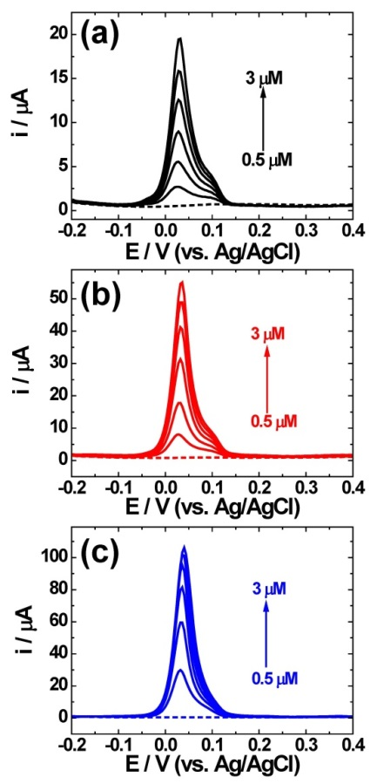
Fig. S5. SWASV of nanoplate Au electrodes to As(III) standard solutions in 1 M HCl (a) at a deposition time of 50 s, (b) at 150 s and (c) at 400 s.
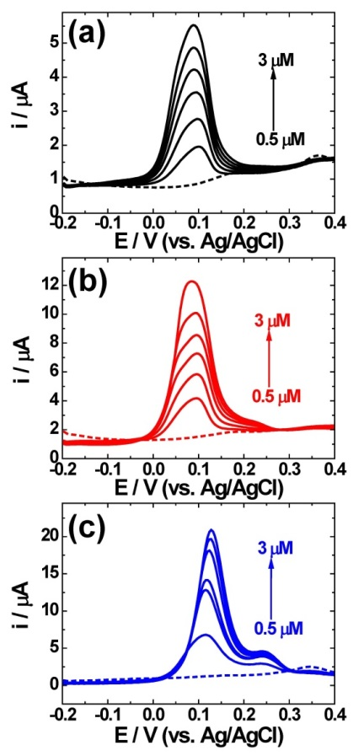
Fig. S6. SWASV response of flat Au electrodes to various As(III) standard solutions in 1 M HCl with pre-deposition time of (a) 50 s, (b) 150 s, and (c) 400 s.

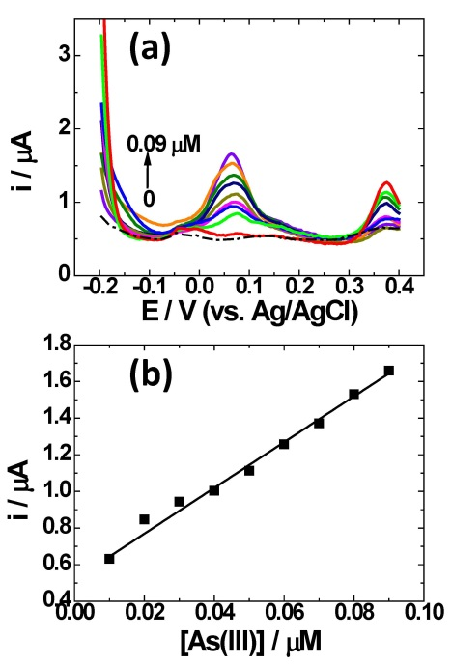
Fig. S7. (a) SWASV responses and (b) calibration plots for As detection on nanoplate Au electrodes for the evaluation of the detection limit.

