Supporting Information

Hydrogen production from water electrolysis driven by high membrane voltage of reverse electrodialysis
Ji-Hyung Han, Hanki Kim, Kyo-Sik Hwang, Nam-Jo Jeong, Chan-Soo Kim*

Marine Energy Convergence and Integration Laboratory, Jeju Global Research Center, Korea Institute of Energy Research, 63357, 200 Haemajihaean-ro, Gujwa-eup, Jeju, South Korea
* Corresponding author: E-mail: damulkim@kier.re.kr; Fax: +82-64-805-2203; Tel: +82-64-800-2251

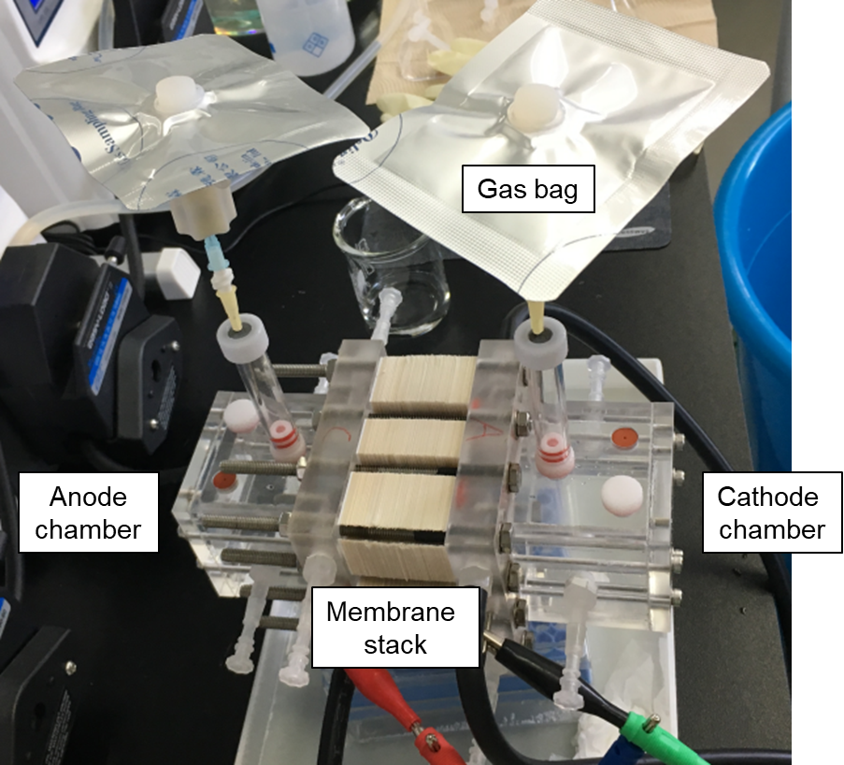
Fig. S1 A photo of the real RED system with simultaneous hydrogen production.

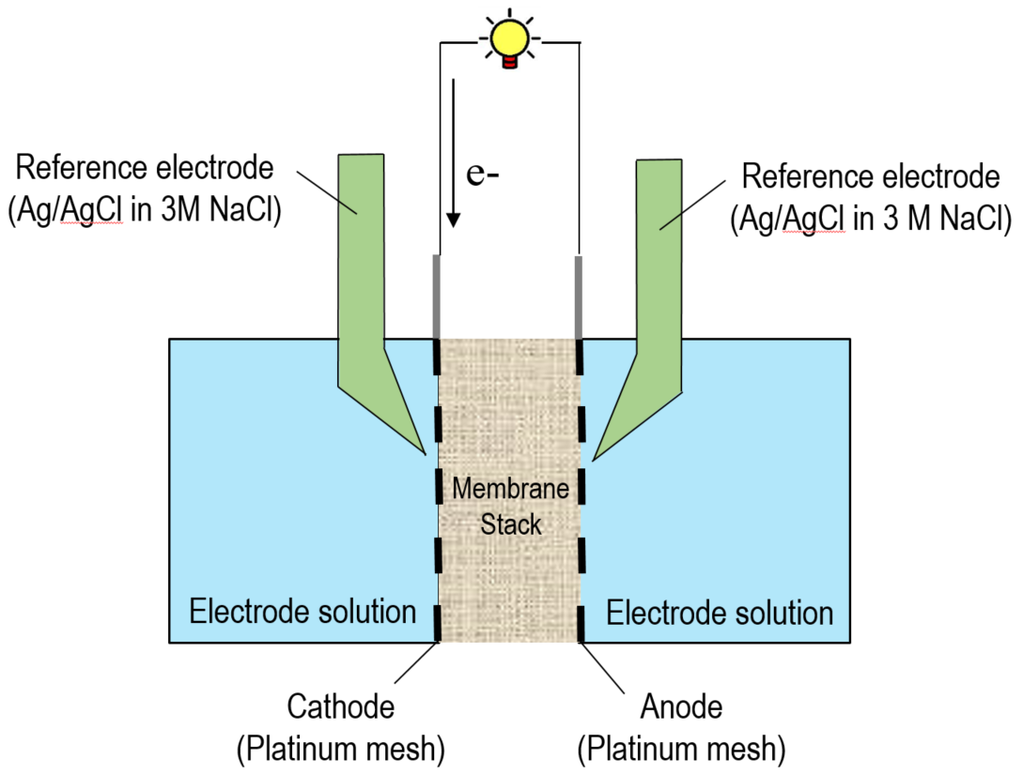
Fig. S2 Measurement of $E_{m, OCV}$ and $E_{m, Pmax}$ using Ag/AgCl reference electrodes. The tips of the reference electrodes were placed at a distance of 2 mm to the cathode and anode. The reference electrodes were connected to an auxiliary port that measures the membrane voltages at no current ($E_{m, OCV}$) and maximum power ($E_{m, Pmax}$).

Fig. S3 Current density of batch-type RED at $P_{max}$ with different cell pairs.

Fig. S4 (a) Open circuit voltage ($E_{m, OCV})$, membrane voltage ($E_{m, Pmax})$, and stack voltage ${(E}_{stack, Pmax})$ at maximum power ($P_{max}$) of batch-type RED with varied cell pairs. All voltages were proportional to the number of cell pairs. This means that all stacked ion exchange membranes participate in producing membrane voltage via the salinity gradient. (b) Voltage ratio of voltage loss (2.2 V) by water electrolysis to $E_{m, Pmax}$ with varied cell pairs.
Peak # | Retention time | Concentration (%) | Compound Name
1 | 1.585 | 71.9 | H₂
2 | 2.111 | 1.78 | O₂
3 | 2.922 | 28.4 | N₂

Table S1. Composition of product gas from the cathode of the RED stack.

